Key Learning Objectives
- Basic Sentence Patterns
- Adverbials
- Basic Diagramming
- Conjunction, Compound and Complex Sentences

Test Sections
Multiple Choice: 30 points
- 15 questions at 2 points each
- 20 minutes

Sentence Labeling 30 points
- 5 questions at 6 points each
- 20 minutes

Sentence Diagrams: 40 points
- 5 diagrams at 8 points each
- 20 minutes

Sentence Creation Bonus: 12 points
- 4 questions at 3 points each
- 10 minutes

Section A: Multiple Choice
Question One: Which of the following sentence patterns best describes the sentence below? (2 pts)
Answer:_____
Sentence: Regrettably, I always gave that bully my lunch money.
- Linking Verb with a Subject Complement (Noun Phrase)
- Transitive Verb with a Direct Object and an Indirect Object
- Transitive Verb with a Direct Object and an Object Complement (Noun Phrase)
- Intransitive Verb

Question Two: Which of the following sentence patterns best describes the sentence below? (2 pts)
Answer:_____
Sentence: Next summer, I will nap peacefully on the sunny beaches of Pisco, Peru.
- Linking Verb with a Subject Complement (Noun Phrase as the Complement)
- Transitive Verb with a Direct Object and an Indirect Object
- Transitive Verb with a Direct Object and an Object Complement (Noun Phrase)
- Intransitive Verb

Question Three: Which of the following sentence patterns best describes the sentence below? (2 pts)
Answer:_____
Sentence: John is very tall in his new boots.
- Ditransitive with a Direct Object and Object Complement (Adjective Phrase as the Complement)
- Be-verb (Copular) with a Subject Complement (Adjective Phrase as the Complement)
- Be-verb (Copular) with a Subject Complement (Noun Phrase as the Complement)
- Linking Verb with a Subject Complement (Adjective Phrase as the Complement)

Question Four: Which of the following sentence patterns best describes the sentence below? (2 pts)
Answer:_____
Sentence: The test seemed very easy in retrospect.
- Transitive Verb with a Direct Object and Object Complement (Noun Phrase as the Complement)
- Transitive Verb with a Direct Object and Object Complement (Adjective Phrase as the Complement)
- Linking Verb with a Subject Complement (Adjective Phrase as the Complement)
- Be-Verb (Copular) with a Subject Complement (Adjective Phrase as the Complement)

Question Five: Which of the following sentence patterns best describes the sentence below? (2 pts)
Answer:_____
Sentence: After much deliberation, we named the puppy Banana.
- Transitive Verb with a Direct Object and Object Complement (Noun Phrase as the Complement)
- Transitive Verb with a Subject Complement (Noun Phrase as the Complement)
- Linking Verb with a Subject Complement (Adjective Phrase as the Complement)
- Transitive Verb with a Direct Object and Indirect Object

Question Six: Which of the answers below is serving as an Adverbial in this sentence? (2 pts)
Answer:_____________
Sentence: Normally, my friend with a boat always brings his mother a hot dinner.
- “with a boat”
- “his mother
- “Normally”
- ‘a hot dinner”

Question Seven: Which of the answers below is serving as a Subject Complement in this sentence? (2 pts)
Answer:_____________
Sentence: Despite her best efforts, my intelligent sister never became a professor like her friends.
- “her best efforts”
- “became”
- “a professor”
- “like her friends”

Question Eight: Which of the answers below is serving as a Direct Object in this sentence? (2 pts)
Answer:_____________
Sentence: Our dear old mother sent a care package to her auntie.
- “her auntie”
- “sent”
- “Our dear old mother”
- “a care package”

Question Nine: Which of the answers below is serving as an Indirect Object in this sentence? (2 pts)
Answer:_____________
Sentence: The old wizard handed the knight a glowing sword with a flourish.
- “handed”
- “the knight”
- “a glowing sword”
- “with a flourish”

Question Ten: Which of the answers below is serving as an Object Complement in this sentence? (2 pts)
Answer:_____________
Sentence: The Admiral appointed him a temporary captain during the battle.
- “The Admiral”
- “him”
- “a temporary captain”
- “during the battle”

Question Eleven: What type of phrase below best describes the Direct Object in this sentence? (2 pts)
Answer:_____________
Sentence: My little sister considers Justin Timberlake very attractive.
- Noun Phrase
- Adjective Phrase
- Prepositional Phrase
- Adverb Phrase

Question Twelve: What type of phrase below best describes the Subject Complement in this sentence? (2 pts)
Answer:_____________
Sentence: Those ninjas with their throwing stars always seem so accurate in the dark.
- Adverb Phrase
- Prepositional Phrase
- Adjective Phrase
- Noun Phrase

Question Thirteen: What type of phrase below best describes the Subject Complement in this sentence? (2 pts)
Answer:_____________
Sentence: My neighbor’s lawn mower is a real pain early in the morning.
- Noun Phrase
- Prepositional Phrase
- Adjective Phrase
- Adverb Phrase

Question Fourteen: What type of phrase below best describes the Object Complement in this sentence? (2 pts)
Answer:_____________
Sentence: Bill called his History test most heinous.
- Noun Phrase
- Prepositional Phrase
- Adjective Phrase
- Adverb Phrase

Question Fifteen: What type of phrase below best describes the Object Complement in this sentence? (2 pts)
Answer:_____________
Sentence: The CEO named that idiot employee of the month.
- Prepositional Phrase
- Adjective Phrase
- Adverb Phrase
- Noun Phrase

Part B: Sentence Patterns: Labeling and Diagramming – 10 pts each
Instructions: For each sentence below, take three steps
- Label the words, phrases, and roles
- Answer the question below the sentence
- Draw a tree diagram as we have practiced in class.

At the end of this exam, you can find several blank pages to use for practicing your diagrams if you choose to.
Key
Parts of Speech  - Noun = N  - Verb = V  - Adjective = Adj  - Adverb = Adv  - Determiner = Det  - Preposition = Prep  - Pronoun = Pro  - Interjection = Intj  - Conjunction = Conj  - Relativizer = Rel  - Complementizer = Comp  Phrase Types  - Noun Phrase = NP  - Verb Phrase = VP  - Adjective Phrase = ADJP  - Adverb Phrase = ADVP  - Prepositional Phrase = PP | Roles  - Subject = Subj  - Predicate = Pred  - Adverbial = Advl  - Subject Complement = SC  - Direct Object = DO  - Indirect Object = IO  - Object Complement = OC  Clauses  - Sentence = S  - Independent Clause = IC  - Dependent Clause = DC  - Relative Clause = RC  - Complement Clause = CC  Sentence Patterns  - Copular Be  - Linking Verb  - Intransitive  - Transitive  - Ditransitive with Direct Object and Indirect Object  - Ditransitive with Direct Objecte and Object Complement

Question 16: My dad called me quite foolish after my wreck.
QUESTION: What sentence pattern is this sentence?

ROLE | Subj |  | Pred | DO | OC |  | Advl
PHRASE | NP |  | VP | NP | ADJP |  | PP
Word | My | dad | called | me | quite | foolish | after | my | wreck
Part of Speech | Det | N | V | Pro | Adv | Adj | Prep | Det | N

Question Sixteen: Identify the Phrase Type and Role for each empty blank (6 pts)
Sentence: In summer, he is very happy on his yacht.
ROLE | Adverbial |  | Subject | Predicate | Subject Complement |  | Adverbial
PHRASE | PP |  | NP | MVP | ADJP |  | PP
Word | In | summer | he | feels | very | happy | on | his | yacht
Part of Speech | Prep | N | Pro | V | Adv | Adj | Prep | Det | N

Question Seventeen: Identify the Phrase Type and Role for each empty blank (6 pts)
Sentence: My father was often a manager of a restaurant.
ROLE | Subject |  | Predicate | Adverbial | Subject Complement
PHRASE | NP |  | MVP | ADVP | NP
Word | My | father | was | often | a | manager | of | a | restaurant
Part of Speech | Det | N | V | Adv | Det | N | Prep | Det | N

Question Eighteen: Identify the Phrase Type and Role for each empty blank (6 pts)
Sentence: Frequently, he tells them dangerous secrets.
ROLE | Adverbial | Subject | Predicate | Indirect Object | Direct Object
PHRASE | ADVP | NP | MVP | NP | NP
Word | Frequently | He | Tells | Them | Dangerous | Secrets
Part of Speech | Adv | Pro | V | Pro | Adj | N

Question Nineteen: Identify the Phrase Type and Role for each empty blank (6 pts)
Sentence: People under pressure consider everyone potentially stressful, unfortunately
ROLE | Subject |  |  | Predicate | Direct Object | Object Complement |  | Adverbial
PHRASE | NP |  |  | MVP | NP | ADJP |  | ADVP
Word | People | under | pressure | consider | everything | potentially | stressful | unfortunately
Part of Speech | N | Prep | N | V | Pro | Adv | Adj | Adv

Question Twenty: Identify the Phrase Type and Role for each empty blank (6 pts)
Sentence: In the end, people show loved ones support.
ROLE | Adverbial |  |  | Subject | Predicate | Indirect Object |  | Direct Object
PHRASE | PP |  |  | NP | MPV | NP |  | NP
Word | In | the | end | people | provide | loved | ones | support
Part of Speech | Prep | Det | N | N | V | Adj | Pro | N

Question Twenty One: Please label the sentence pattern and diagram this sentence (8 pts)
Sentence: Previously, those pretty birds were absent for the winter.
A: Sentence Pattern: Copular Be
B: Diagram the Sentence
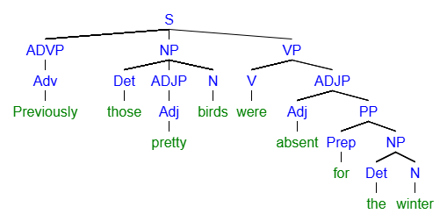
Question Twenty-Two: Please label the sentence pattern and diagram this sentence (8 pts)
Sentence: The queen dubbed him a knight of the realm.
A: Sentence Pattern: Ditransitive with Direct Object and Object Complement
B: Diagram the Sentence
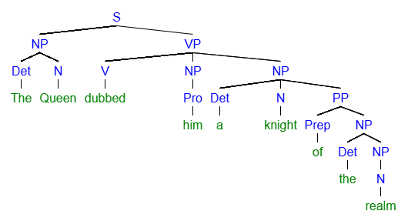
Question Twenty-Three: Please label the sentence pattern and diagram this sentence (8 pts)
Sentence: On my birthday, I always feel extremely lucky.
A: Sentence Pattern: Linking Verb
B: Diagram the Sentence
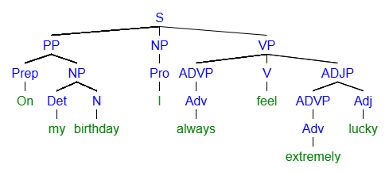
Question Twenty-Four: Please label the sentence pattern and diagram this sentence (8 pts)
Sentence: Her sister offered Tudy some good advice actually.
A: Sentence Pattern: Ditransitive with Direct Object and Indirect Object
B: Diagram the Sentence
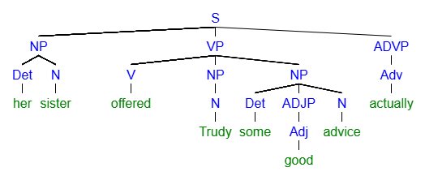
Question Twenty-Five: Please label the sentence pattern and diagram this sentence (8 pts)
Sentence: Eventually, all the energy in the universe dissipates into the endless quiet of entropy.
A: Sentence Pattern: Intransitive
B: Diagram the Sentence
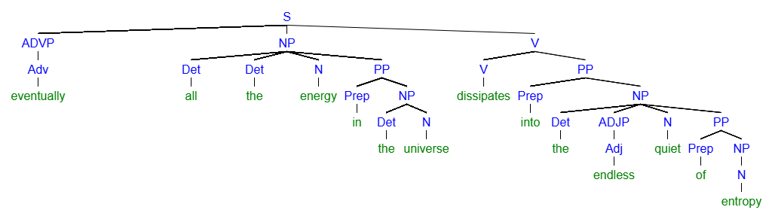
Section D: Sentence Creation - Bonus
For section D and the Bonus, please write all the new sentences about a movie, book, or TV show you like. Feel free to reuse the same ideas and characters from the movie, book, or TV show as many times as you like.
Name the movie, book, or TV show here:________________________________________________________________________

Question Twenty-Six: (3 pts bonus)
Write a sentence containing a linking verb.

Question Twenty-Seven: (3 pts bonus)
Write a sentence containing a direct object.

Question Twenty-Eight: (3 pts bonus)
Write a sentence containing an indirect object.

Question Twenty-Nine: (3 pts bonus)
Write a sentence containing an object complement.

